**Ex no: STUDY OF HTML TAGS**

**Date:**

**AIM:**

**DESCRIPTION:**

**PROGRAM:**

<!DOCTYPE html>

<html lang="en">

<head>

    <meta charset="UTF-8">

    <meta name="viewport" content="width=device-width, initial-scale=1.0">

    <title>Kamaal Ismaeel K I - Portfolio</title>

</head>

<body>

    <div class="header">

        <div class="logo">Kamaal Ismaeel K I</div>

        <nav class="nav">

            <a href="#">Home</a>

            <a href="#">About</a>

            <a href="#">Projects</a>

        </nav>

    </div>

    <section id="home" class="hero-section">

        <div class="profile-image"></div>

        <h1 class="hero-title">Creative</h1>

        <h2 class="hero-subtitle">Developer</h2>

        <p class="hero-description">

            Turning thoughts into interfaces and logic into legibility<br>

            — I write software that's as optimized as it is obsessive.

        </p>

        <div class="buttons">

            <a href="#" class="btn btn-primary">View My Work</a>

        </div>

    </section>

    <section id="projects" class="projects-section">

        <h2 class="section-title">Featured Projects</h2>

        <div class="projects-grid">

            <div class="project-card">

                <div class="project-icon flask-icon">🌐</div>

                <h3 class="project-title">Blog-Post Web Application</h3>

                <p class="project-description">

                    Developed a full-stack blog platform using Python and Flask with user authentication and role-based access control. Implemented CRUD operations for blog posts with user-specific management capabilities.

                </p>

                <div class="tech-tags">

                    <span class="tech-tag">Python</span>

                    <span class="tech-tag">Flask</span>

                    <span class="tech-tag">SQLite</span>

                    <span class="tech-tag">Jinja2</span>

                    <span class="tech-tag">Bootstrap</span>

                </div>

            </div>

            <div class="project-card">

                <div class="project-icon scraping-icon">🔍</div>

                <h3 class="project-title">LinkedIn-Scraping</h3>

                <p class="project-description">

                    This script scrapes LinkedIn job postings for roles like Frontend Developer, Backend Developer, and QA Writer. The data is saved in one Excel file with auto-adjusted column widths.

                </p>

                <div class="tech-tags">

                    <span class="tech-tag">Python</span>

                    <span class="tech-tag">Selenium</span>

                    <span class="tech-tag">BeautifulSoup</span>

                    <span class="tech-tag">Pandas</span>

                </div>

            </div>

            <div class="project-card">

                <div class="project-icon dashboard-icon">📊</div>

                <h3 class="project-title">Business Intelligence - Dashboard</h3>

                <p class="project-description">

                    A clean and modern BI dashboard built with TypeScript and React. Uses ShadCN UI components and Tailwind CSS to display KPIs and charts with a sleek design.

                </p>

                <div class="tech-tags">

                    <span class="tech-tag">React / Next.js</span>

                    <span class="tech-tag">Tailwind CSS</span>

                    <span class="tech-tag">ShadCN UI</span>

                    <span class="tech-tag">Chart.js</span>

                </div>

            </div>

        </div>

    </section>

</body>

</html

**OUTPUT:**

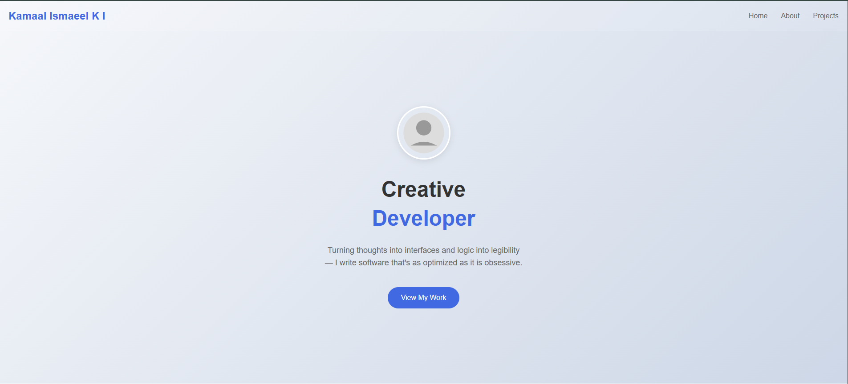

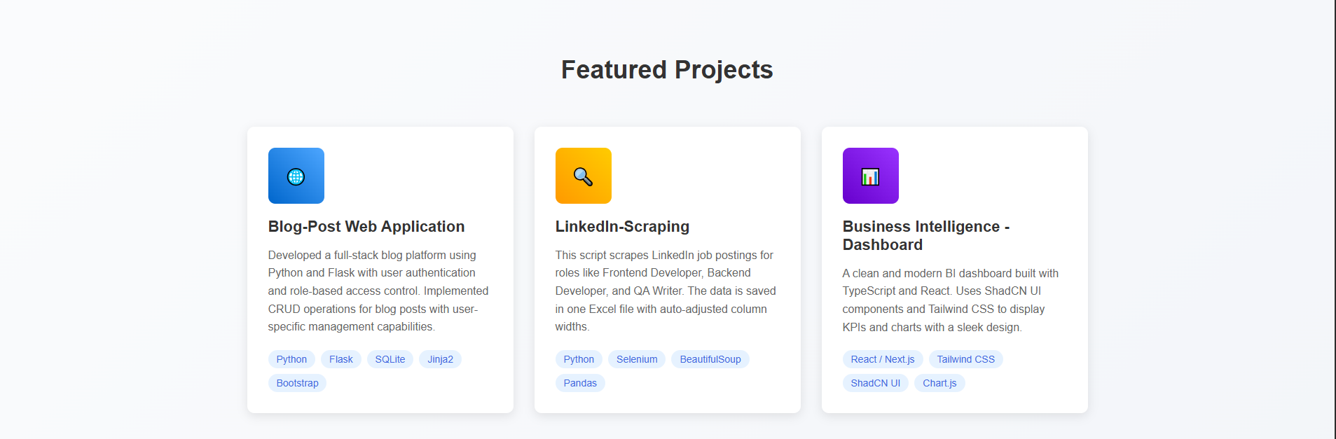

**RESULT:**